|  |  |
| --- | --- |
| **OBSERVATION** |  |
|  |  |

**Primary Audience:** Teacher

**Purpose of Document:** This guide outlines the steps for the Teacher completing the 1st Observation steps. Activities in ***green*** are teacher steps/ activities in ***red*** are evaluator steps.

1. Click on the **My Evaluation** tab.

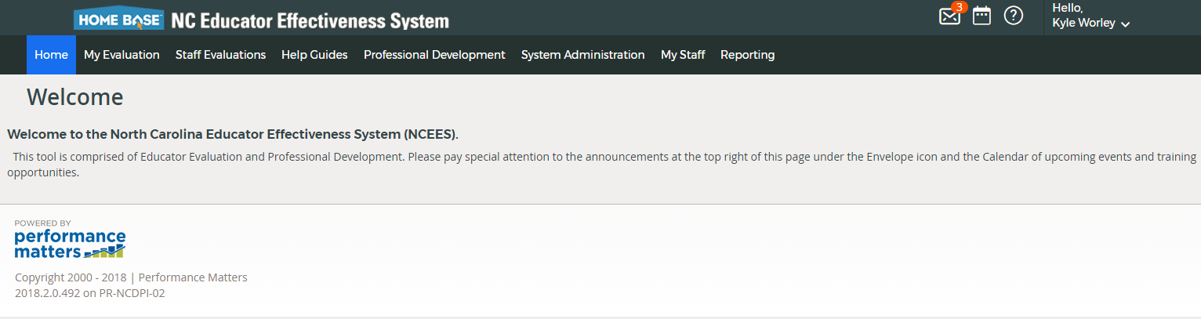

1. Click on your **Evaluation Plan-** Standard (SPII) or Comprehensive (SPI or less than)

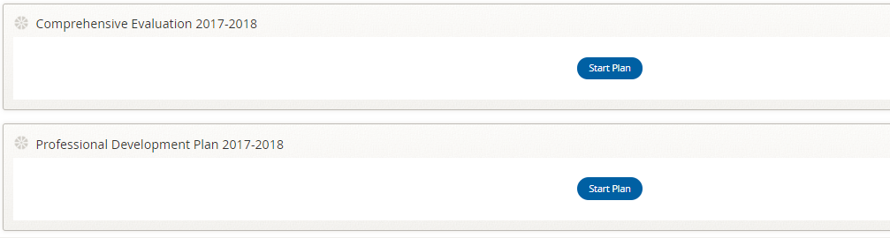

1. Click on **Observation #1**

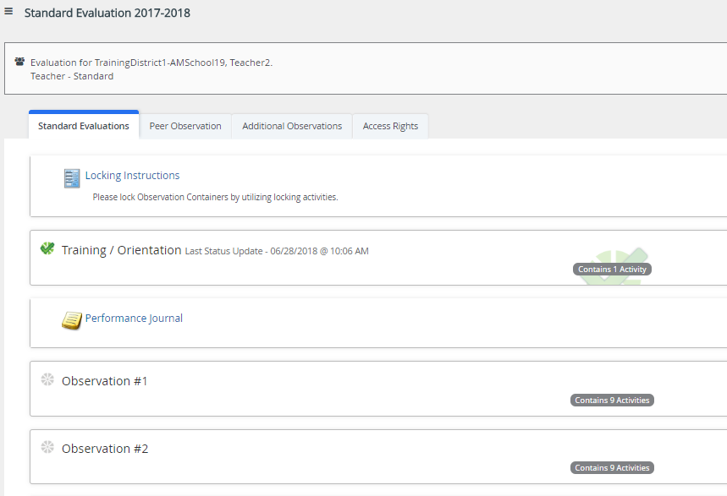

The following containers display the required steps of the **Observation #1** container:

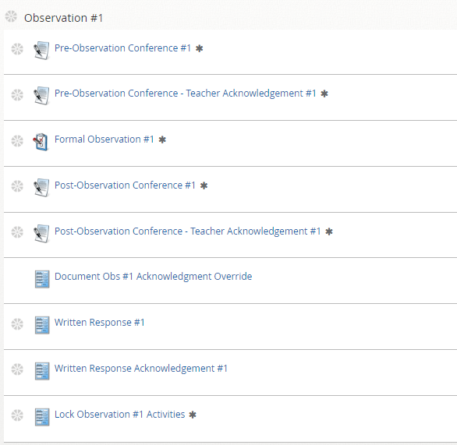

The following status icons can be found throughout the evaluation plan in the system. Keep these in mind when completing the activities within the containers.

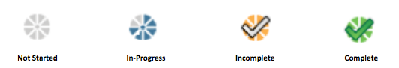

***Activity 1: Pre-Observation Conference #1:***

Once the Evaluator has completed the Pre-Observation Conference, there will be a green check mark.

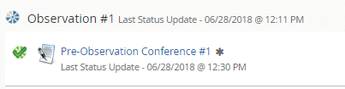

***Activity 2: Pre-Observation Conference – Teacher Acknowledgement:***

1. Click the **Pre-Observation Conference-Teacher Acknowledgement**.



1. After reviewing the notes and artifacts for the observation, click **Acknowledge.**

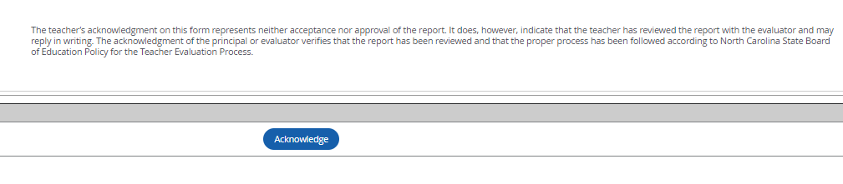

1. The Pre-Observation Conference-Teacher Acknowledgement will be **complete**

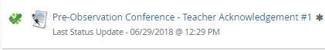

***Activity 3: Formal Observation #1:***

The Evaluator will fill out the Formal Observation #1. After the Post-Observation conference the Evaluator will share and finalize the Formal Observation with the teacher.

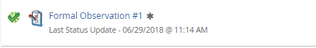

***Activity 4: Post-Observation Conference:***

Once the Evaluator has completed the Post-Observation Conference, there will be a green check mark.

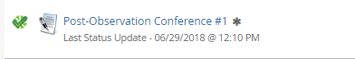

***Activity 5: Post-Observation Conference – Teacher Acknowledgement***

1. Click the **Post-Observation Conference - Teacher Acknowledgement**.



1. After reviewing the comments and artifacts from the observation, click Acknowledge



1. The Post-Observation Conference-Teacher Acknowledgement will be **complete**



***Activity 6: Written Response (Optional)***

1. Click **Written Response** to provide a response.



1. Click the **Edit**

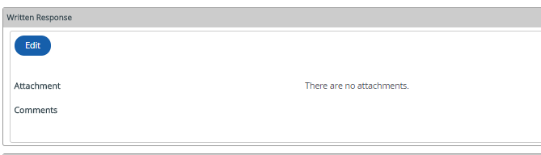

1. Enter **comments** in the comments box and/or **add attachments**.

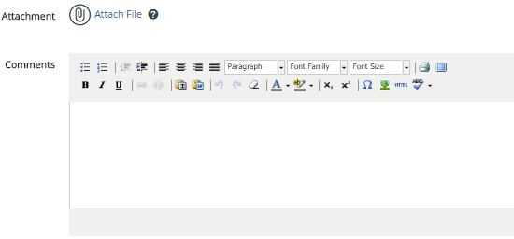

1. Click **Save and Exit** when completed.

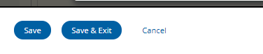

1. Once you are finished with your written response, click **Mark Complete.**

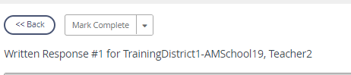

1. The Written Response will be **complete**

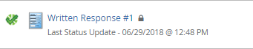

***Activity 7: Written Response Acknowledgement:***

If the teacher completes a **Written Response**, the Evaluator will need to complete the **Written Response Acknowledgement.**



***Activity 8:*** ***Lock Observation #1 Activities:***

The Evaluator will Lock Observation #1 Activities once all items under Observation #1 have a green check.

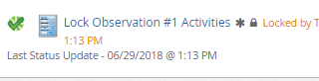

**Observation 1** will be **complete**-

